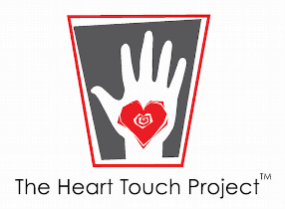
Bequests
A gift to The Heart Touch Project in your will or living trust allows you to retain your assets during your lifetime. This is the simplest planned gift to implement or change should you ever need the assets during your lifetime.
How it works:
- You make The Heart Touch Project a beneficiary in your will or a designated beneficiary of your retirement plan, life insurance policy or another asset.
- The Heart Touch Project receives your gift when your estate is settled.
The following information is intended to help you and your attorney in drafting a bequest.
Legal Name The Heart Touch Project
Address 3400 Airport Ave #42, Santa Monica, CA 90405
Tax ID # 95-4529022
Nonprofit Status Active and in good standing

Sample Language:
Unrestricted Gifts – A gift that can be used where the need is greatest.
I give, devise, and bequeath to The Heart Touch Project, Santa Monica, CA, (insert dollar amount) Dollars* to be used for its general purposes.
Residuary Bequest – Leaves any remainder after all other bequests have been paid.
I give, devise, and bequeath to The Heart Touch Project, Santa Monica, CA, (insert percentage amount) percent of the residue of my estate to be used for its general purposes.
Contingency Gift – Takes effect only if a primary intention can’t be met.
In the event that (insert name) predeceases me, I give, devise, and bequeath his/her bequest or share to The Heart Touch Project, Santa Monica, CA, to be used for its general purposes.

